clear;
clc;
p = params();
Uopt = dp_solver(p);
[omega_dp, T_dp] = simulate_dp(p, Uopt);
[omega_base, T_base] = simulate_baseline(p);
plots(p, omega_dp, T_dp, omega_base, T_base);
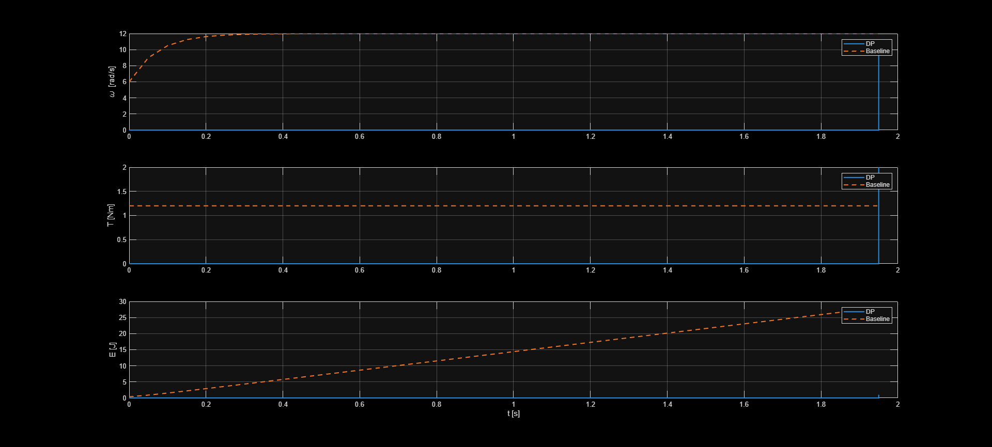
Published with MATLAB® R2025b

